Soorty Launches New Seasonless II Collection
Continues to Innovate with Sustainability and Production Practices

Soorty, Pakistan's largest vertically integrated denim producer, is pleased to announce their second seasonless collection.

For decades, the traditional seasonal calendar has served the industry well. With fashion weeks losing influence, the seasonal calendar is outdated and no longer relatable due to climate change which blurred the line between seasons and accessibility. Going seasonless emphasizes Soorty’s focus on what is necessary and take a meaningful action to overhaul the existing system in the fashion industry.

Being a design-centric company, Soorty believes in design which allows utilization of correct resources efficiently. This denim manufacturer focuses ongoing and growing concepts, as part of the strategy to revise outdated traditions and working on a seasonal production schedule. The manufacturer approaches production as an ongoing process of evolution and considering designing systems and philosophies that will bring the positive impact that the industry needs. Seasonless II focuses on fluidity, not only in terms of seasons and climate change, but also targets a transparent, inclusive, connected, dynamic, genderless and customized future.
As designers, engineers, and stakeholders in the industry, Soorty sees and understands the need to be adaptable and fluid in skills and practices, and uses technology as a tool to re-shape the systems as well as products. They are welcoming a radical shift in their production cycle towards minus zero waste to transform the supply chain into a value chain by producing, using and extracting less and focusing on three key factors: Longevity, adaptability, and intelligence in denim through different initiatives using this concept.
- ReSync – Adaptive jeans that minimize the industry's waste. Designed for today’s environmentally, socially and economically conscious consumer
- REDREAM – Rewriting the denim rulebook with new values of responsibility over aesthetics.
- REFINE – Authentic Denim Looks in Adaptable Compositions. Curated for today’s consumer who needs less but cares more.

As one of the largest vertical denim manufacturers in the world, Soorty knows that production at scale has the power to change things and they are dedicated to making their impact on the environment and societies, a positive one, by using less of what is limited while making more and better use of it.

Soorty is truly at the forefront of sustainability, inclusivity, technology and education in the industry.

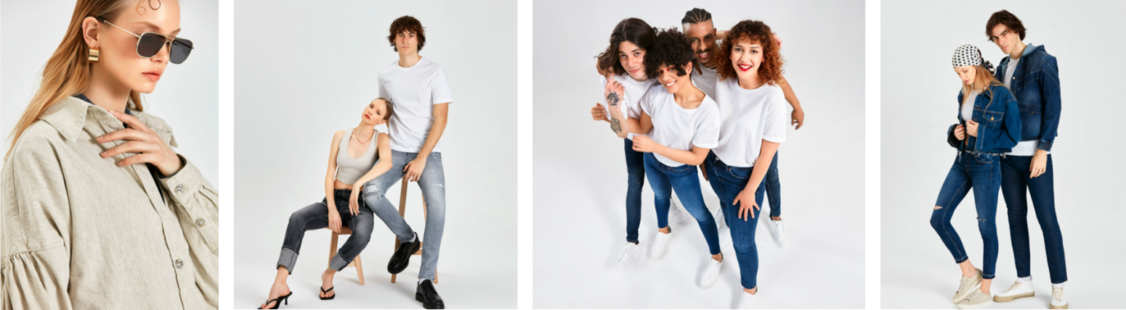
Imagery Courtesy of Soorty HERE

http://www.soorty.com
https://www.future-possibilities.com/
@soortyenterprises

For more information contact nicole@michelemariepr.com

ABOUT SOORTY
Soorty is a family of engineers and designers at heart who need to communicate the possibility of crafting with sustainable innovation. Soorty is envisioning a new business model for the future of the denim industry; bringing the uniquely crafted engineering expertise together with contemporary communication tools that see, hear and reflect the consumers' true needs, options, wants and desires.

Our understanding of sustainability is based on co-creating possibilities for radical responsibility. We are committed to disrupting the denim industry.

